Introduction to Bulk Extractor
Bulk Extractor is a powerful open-source digital forensics tool designed to scan disk images, files, or directories to extract useful information without parsing the file system or its structures. This capability allows it to efficiently process various types of digital media, including hard drives, SSDs, optical media, and mobile devices.


The tool is particularly noted for its speed and thoroughness, as it can process data in parallel across multiple cores, significantly enhancing performance on multi-core machines

.The primary output of Bulk Extractor includes feature files that contain extracted data such as email addresses, URLs, and other significant identifiers. Additionally, it generates histograms that summarize the frequency of these features, which can be crucial for identifying patterns in the data

. This functionality makes it valuable for law enforcement, intelligence agencies, and cybersecurity investigations

Step 1:
Opening the bulk extractor in windows
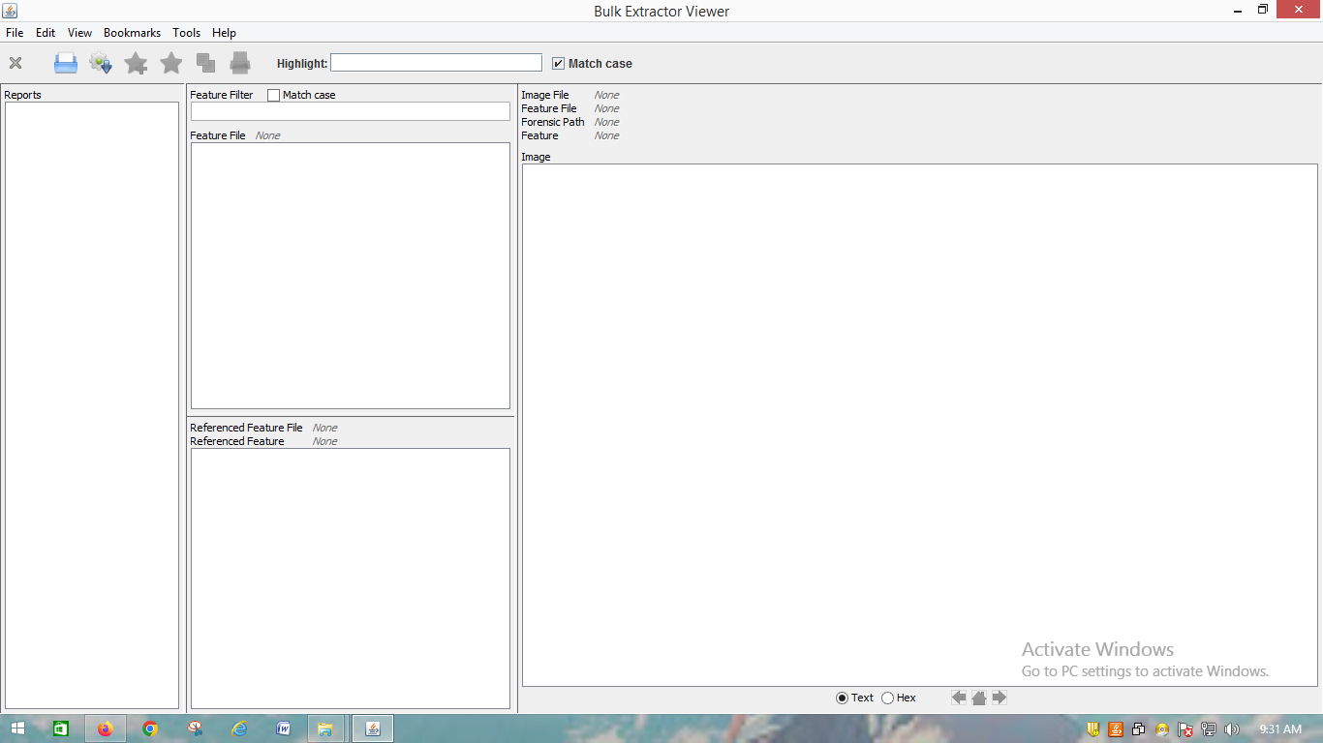

Step 2 :
Downloading the Raw image from github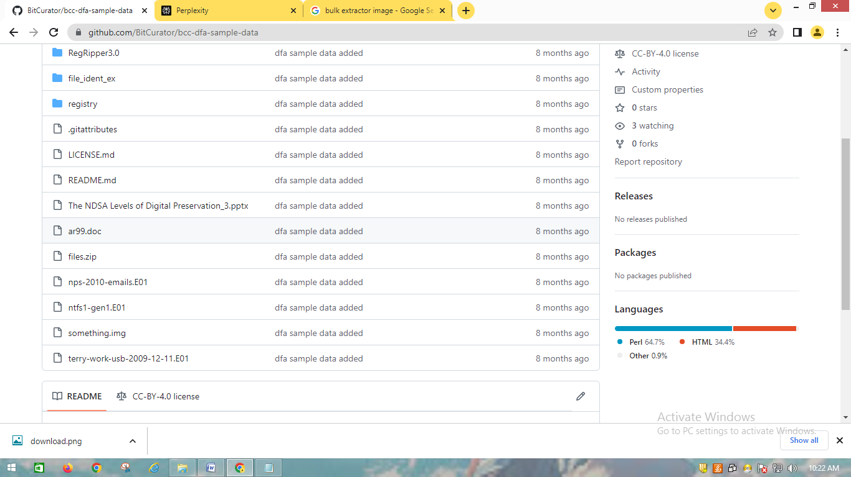
Step 3 :
select the raw image (nps-2010-emails (1).E01 ) and output directory for output (E:\BULK)
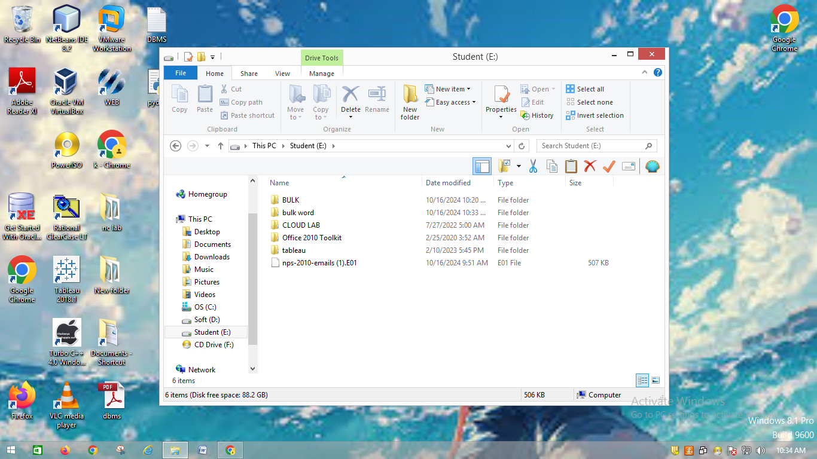
start the bulk_extractor for extracting the metadata
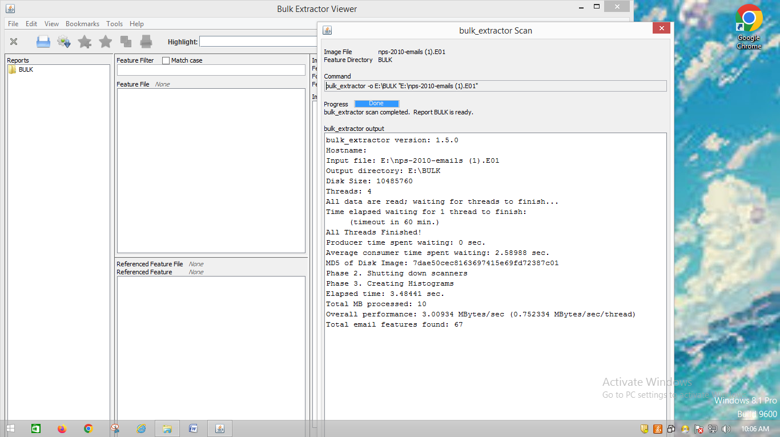
Step 4:
The report is generated in the extracted folder
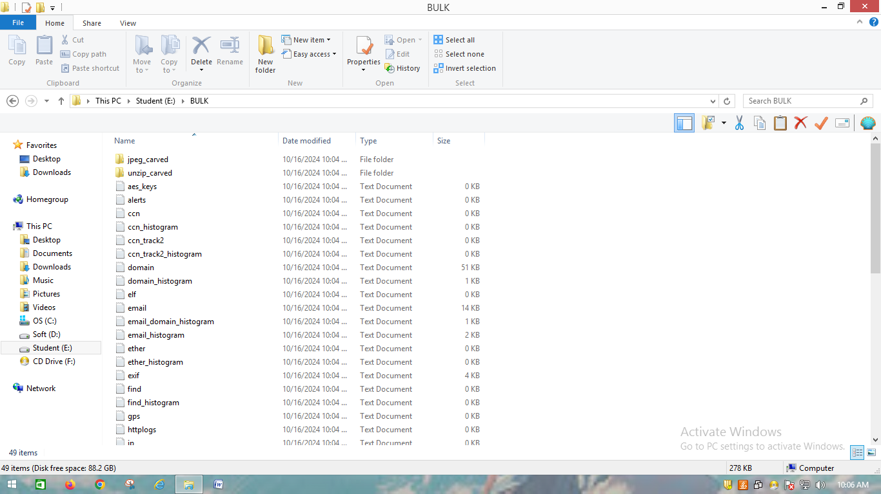
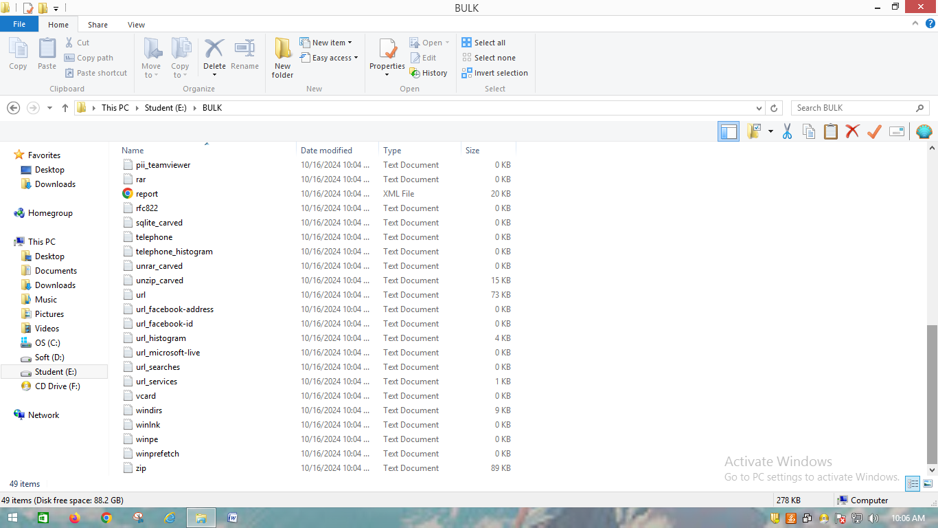
The report is generated in the XML format in the respected user agent : Chrome (Google)

Step 5:
When we click the report.xml we see the respected output
